TOC – EXPERIMENTS

1.Design TM using simulator to accept the input string an bn.

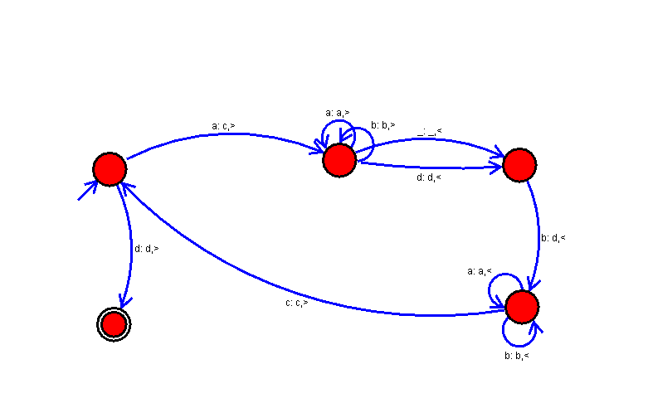

2. Design TM using simulator to accept the input string anb2n.

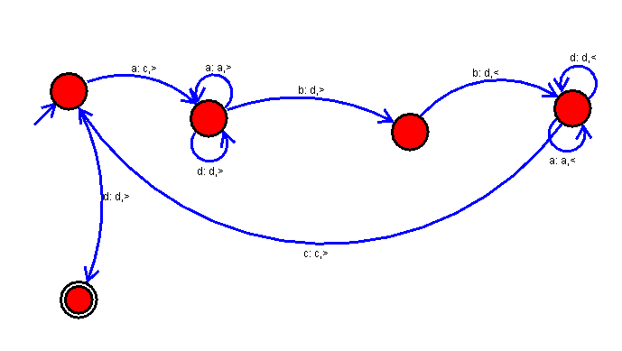

3.Design TM using simulator to perform addition.

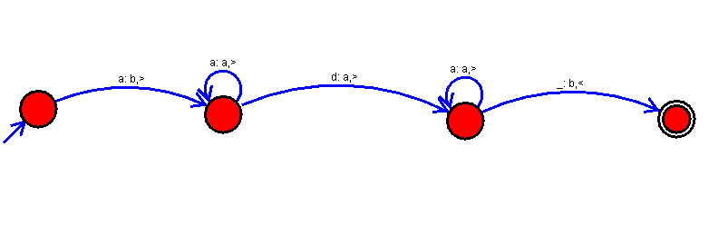

4.Design TM using simulator to perform subtraction.

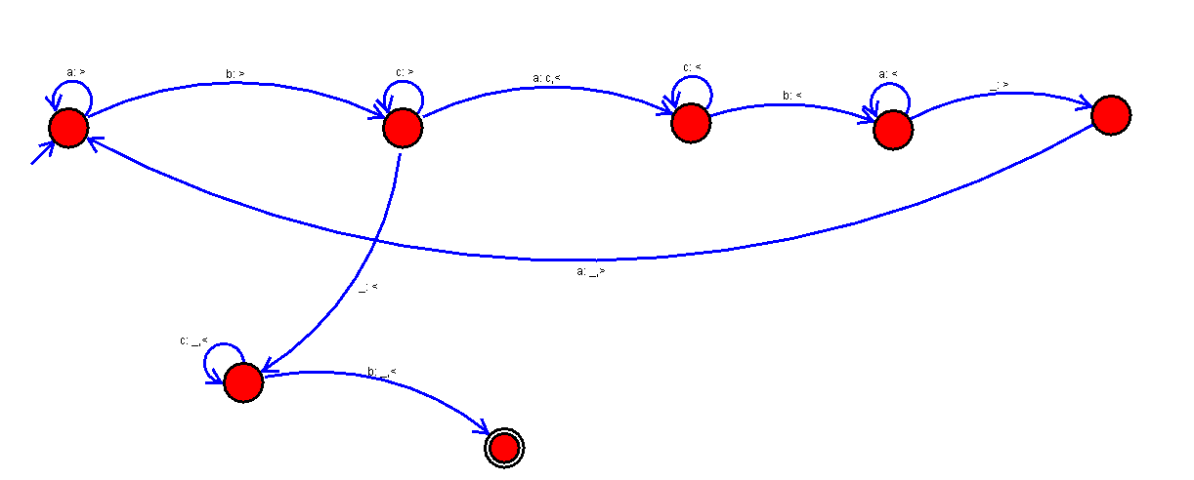

5.Design TM using simulator to accept the string WCW

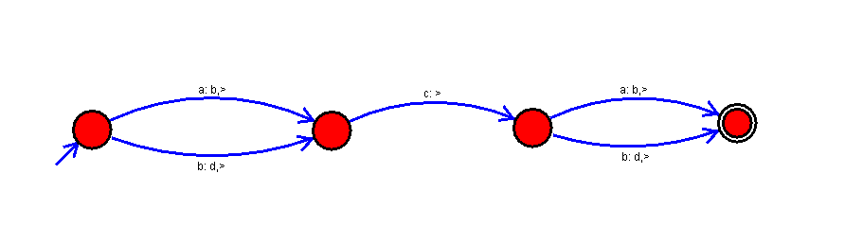

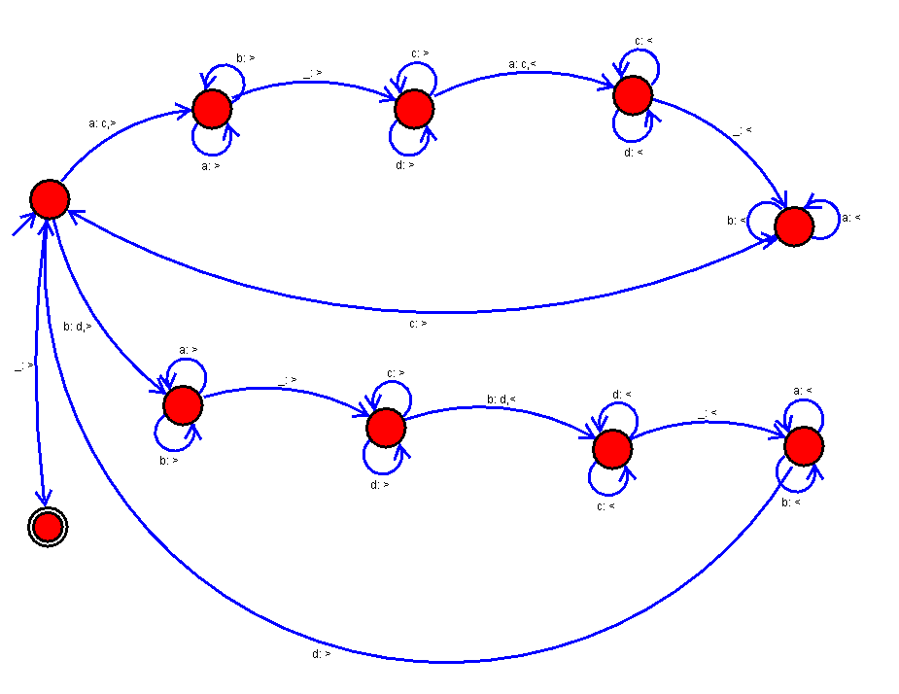

6.Design TM to accept the string palindrome.

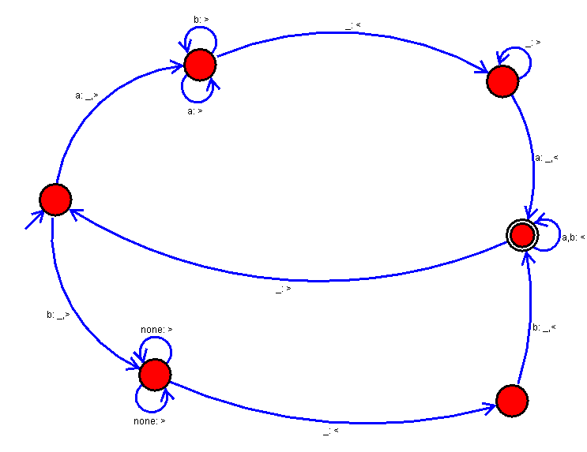

7.Design TM to compare two strings.

